**Tomato Plant Disease Detection From Leaf Images Using**

**Deep Learning**

**Introduction:**

Tomato Plant is prone to having various diseases during its growth stage. If these diseases are not cured on time, they lead to the death of the plant and the harvest does not give a good yield. Moreover, in a tomato farm this disease can be transferred from one plant to other very rapidly. The farmers are concerned about their harvest.

It is not possible for the farmers to pay the agriculture experts hefty fees every time their plants develop a disease. We have come up with a solution to this problem. We have trained an AI model which can be used by farmers to check the disease their tomato plant might be having. The users need to upload image of a tomato leaf to the website and click on the submit button. Our model will give its prediction as to which disease is probable based on the image. The users can then visit the local agriculture store to ask for medicines for particular plant diseases. Our model can predict up to 9 tomato plant diseases and is also capable of pointing out if the plant looks healthy.

This model is useful for farmers, agriculture scientists, home farmers, gardeners, etc. This AI model is made using Convolutional Neural networks and under CNN we will be using transfer learning. Transfer learning has become one of the most common techniques that has achieved better performance in many areas, especially in image analysis and classification. We used Transfer Learning technique ResNet152V2 that is more widely used as a transfer learning method in image analysis, and it is highly effective.

**Technical Architecture:**

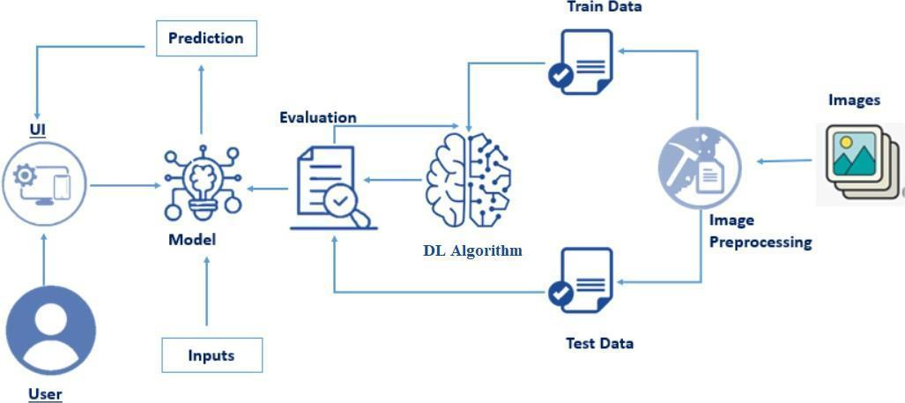

**Prior Knowledge:**

You must have prior knowledge of the following topics to complete this project.

* Deep Learning Concepts
  + CNN: <https://towardsdatascience.com/basics-of-the-classic-cnn-a3dce1225add>
  + ResNet-50: <https://towardsdatascience.com/understanding-and-coding-a-resnet-in-keras-446d7ff84d33>
* Flask: Flask is a popular Python web framework, meaning it is a third-party Python library used for developing web applications.

             Link: <https://www.youtube.com/watch?v=lj4I_CvBnt0>

**Prerequisites:**

To complete this project, you must require the following software’s, concepts and packages

* Anaconda navigator, VS Code and Spyder:
  + Refer the link below to download anaconda navigator
  + Link (VS Code) : <https://youtu.be/1ra4zH2G4o0>
  + Link (Spyder) : <https://youtu.be/5mDYijMfSzs>
* Python packages:
* Open anaconda prompt as administrator
* Type “pip install numpy” and click enter.
* Type “pip install pandas” and click enter.
* Type “pip install tensorflow ==2.3.2” and click enter.
* Type “pip install keras ==2.3.1” and click enter.
* Type “pip install Flask” and click enter.

**Project Objectives:**

* Know fundamental concepts of Deep Learning Concepts :CNN.Resnet152v2
* Gain knowledge in the pre-trained model Resnet152v2.
* Gain knowledge of Web Integration.

**Project Flow:**

* The user interacts with the UI (User Interface) to choose the image.
* The chosen image analyzed by the model which is integrated with flask application.
* The ResNet Model analyzes the image, then the prediction is showcased on the Flask UI.

To accomplish this, we must complete all the activities and tasks listed below

* Data Collection.
  + Create a Train and Test path.
* Data Pre-processing.
* Import the required library
* Configure ImageDataGenerator class
* ApplyImageDataGenerator functionality to Trainset and Test set
* Model Building
  + Pre-trained CNN model as a Feature Extractor
  + Adding Dense Layer
  + Configure the Learning Process
  + Train the model
  + Save the Model
  + Test the model
* Application Building
  + Create an HTML file
  + Build Python Code

**Project Structure:**

Create a Project folder which contains files as shown below

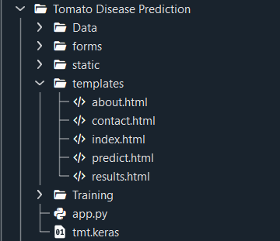

* Static folder contains css files
* Template folder contains all 4 HTML pages.
* Data folder contains Training and Validation images
* Training file consist of train.ipynb , tmt.keras model

**Milestone 1: Collection of Data**

In this project, we have collected images of 10 types of Tomato Leaf images like Heatly, Spider Mites, Yellow leaf curl, etc. and they are saved in the respective sub directories with their respective names.

You can download the dataset used in this project using the below link

Dataset: <https://www.kaggle.com/datasets/kaustubhb999/tomatoleaf>

**Activity 1: Creating training and Testing Dataset**

Here we can see that the training and testing data is given in 2 separate folders.

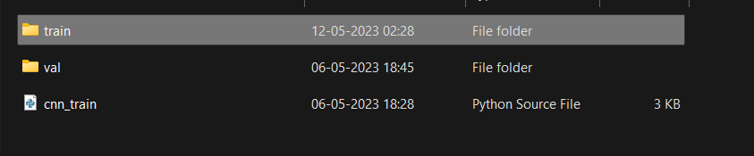

Inside the training folder there are several folders for different classes.

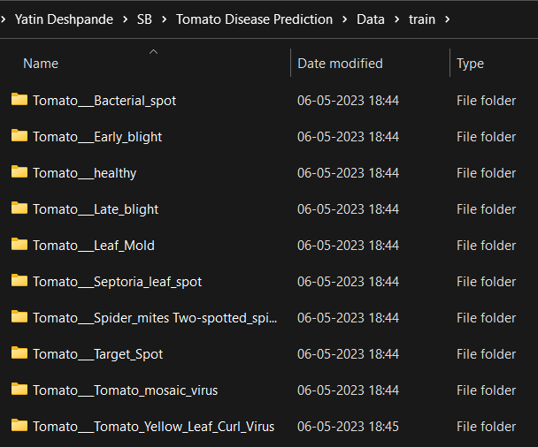

The same is the case for ‘val’ folder.

**Sample data:**

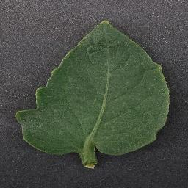 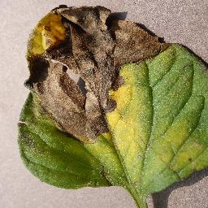

**Milestone 2: Image Pre-processing**

In this milestone, we will be improving the image data that suppresses unwilling distortions or enhances some image features important for further processing, although performing some geometric transformations of images like rotation, scaling, translation, etc.

**Activity 1: Loading the Dataset**

Download the dataset from the Kaggle

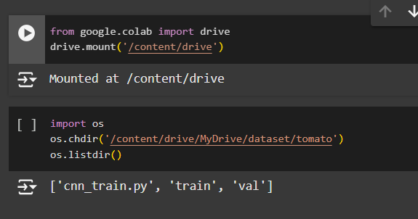

**Activity 2: Import the libraries**

Import the necessary libraries as shown in the image

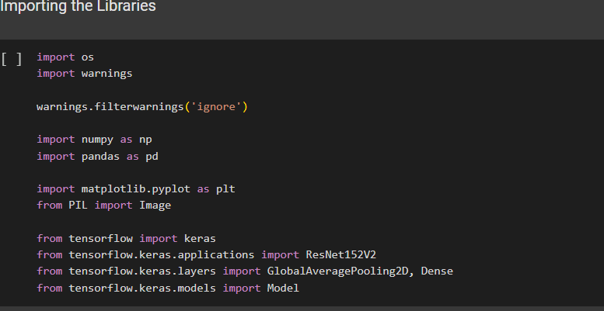

Configure ImageDataGenerator Class

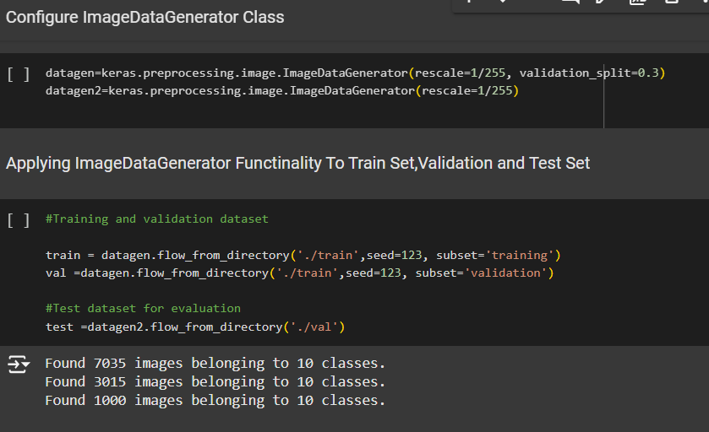

Preview of Images

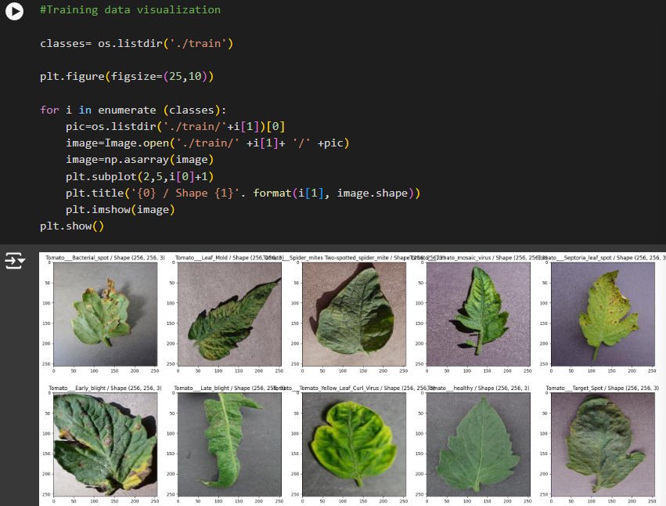

**Milestone 3: Model Building**

**Activity 1: Pre-trained CNN model as a Feature Extractor**

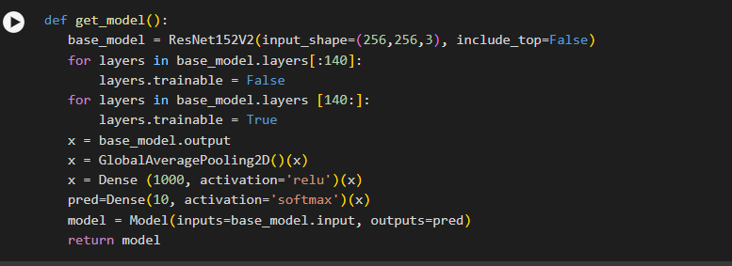

**Activity 2: Adding Dense Layer and Average Pooling layer**

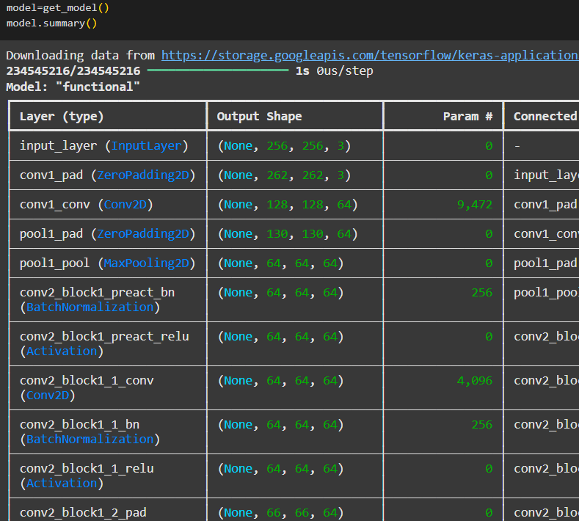

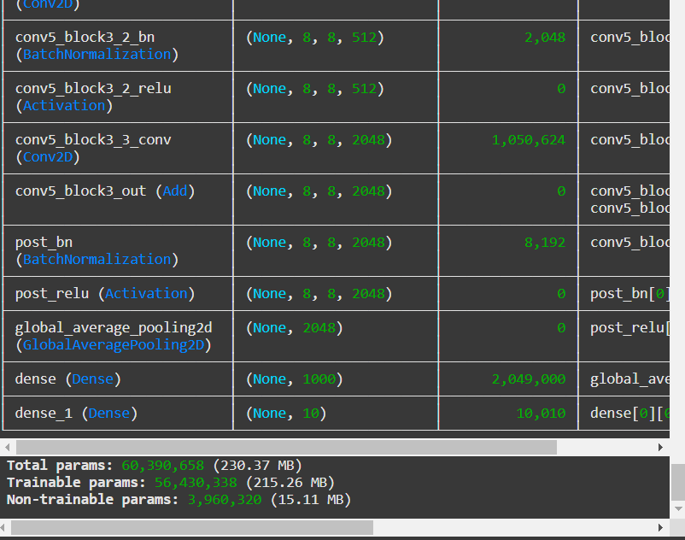

**Activity 3. Configure the Learning Process**



**Activity 4: Training the model**

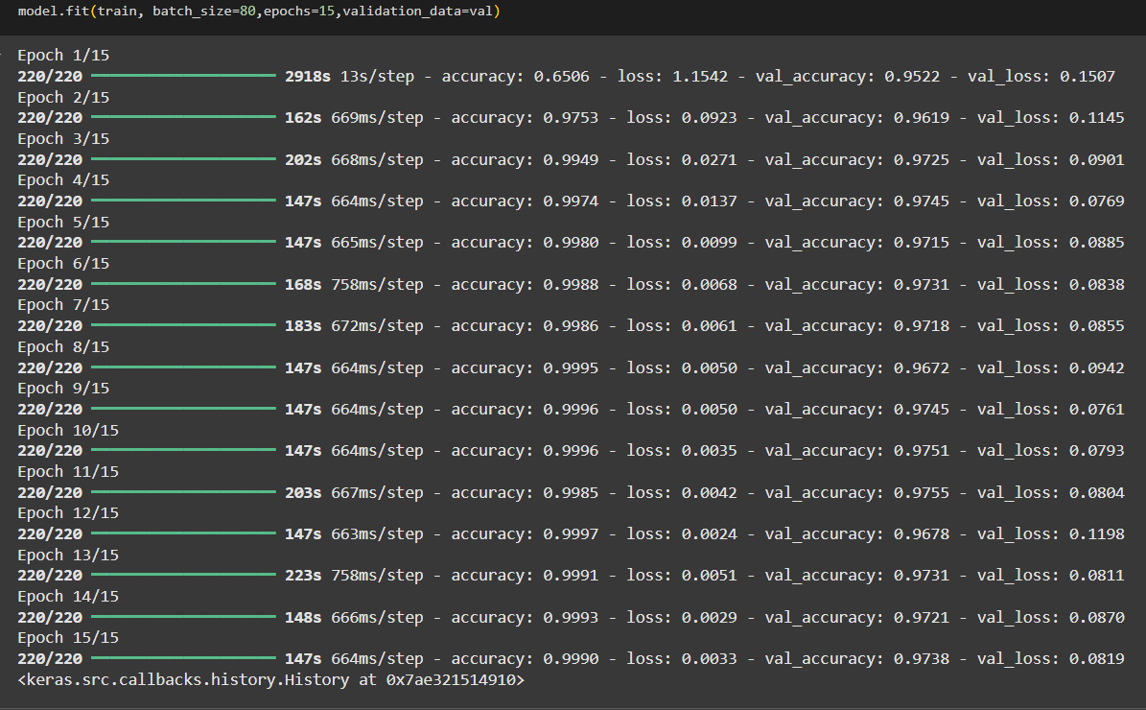

**Activity 5: Testing the model**

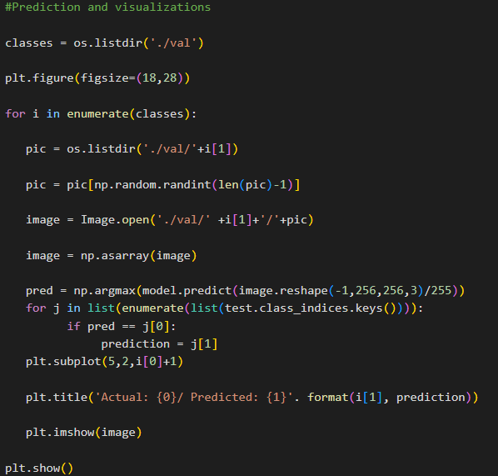

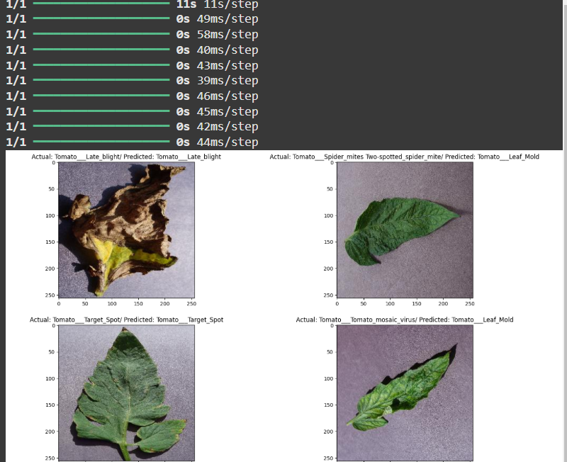

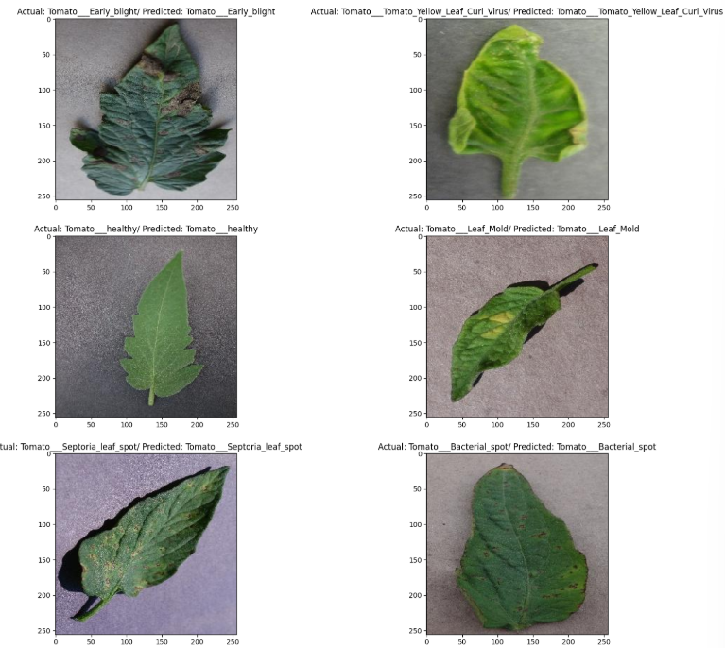

**Milestone 4: Save the model**

The model is saved as tmt.keras. A keras file is a data file saved in the keras format. It contains multidimensional arrays of scientific data. 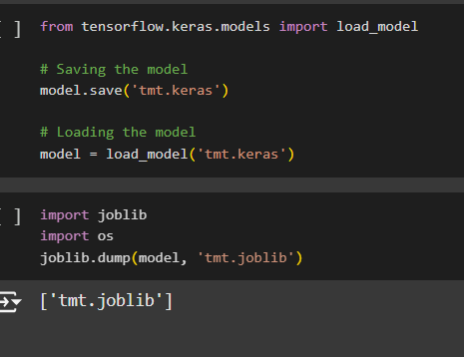

**Milestone 5: Application Building**

In this section, we will be building a web application that is integrated to the model we built. A UI is provided for the user where they have to upload the image for predictions. The entered image is given to the saved model and prediction is showcased on the UI.

This section has the following tasks

* Building HTML Pages
* Building server side script

**Activity 1: Building HTML Pages**

* We use HTML to create the front-end part of the web page.
* Here, we have created 4 HTML pages- home.html, about.html, predict.html,result.html.

**Activity 2: Build Python Code**

Write the below code in Flask app.py python file script to run the Object Project. To upload image in UI, To display the image in UI:

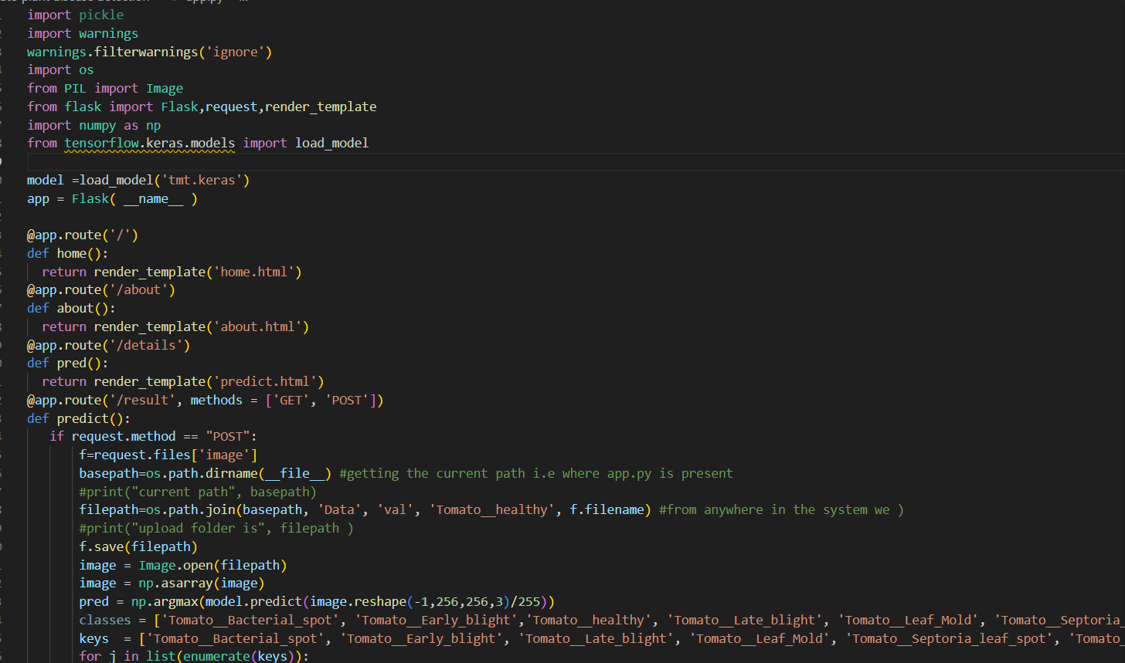

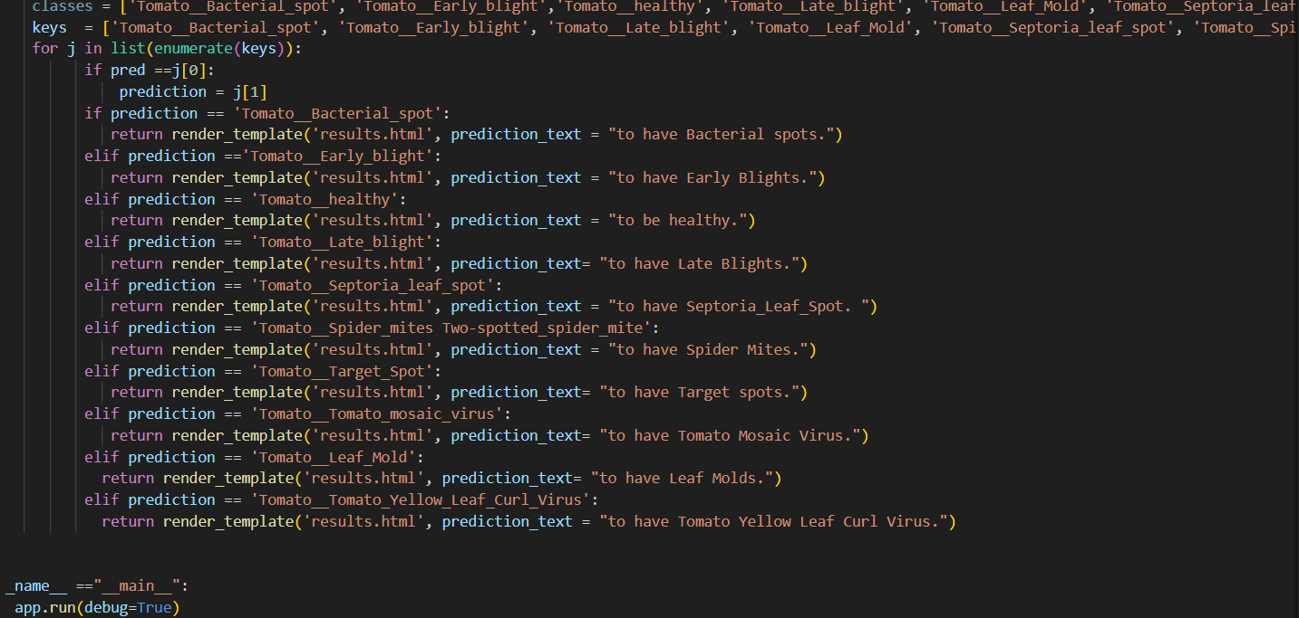

**Getting local host in the terminal while running app.py:**

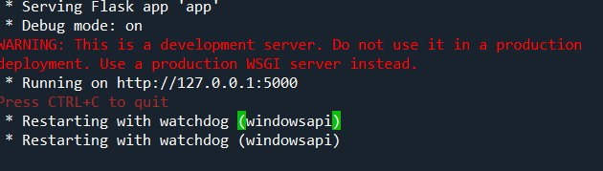

**home.html is displayed below:**

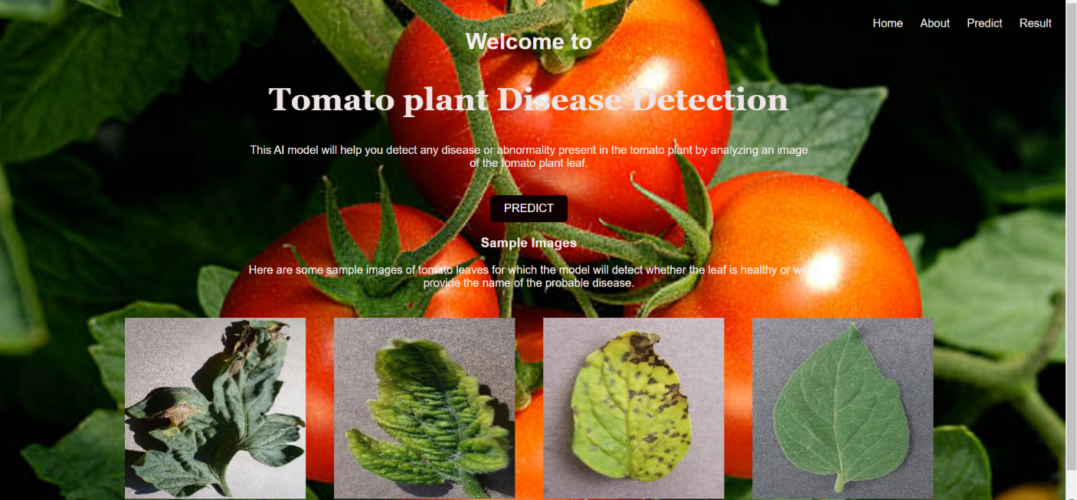

**About.html is displayed below:**

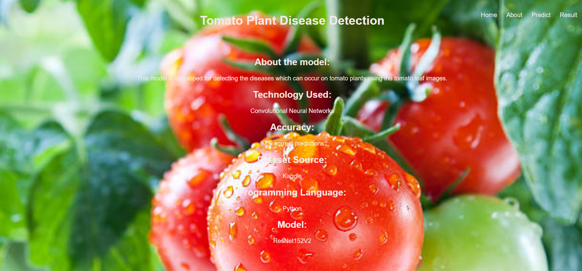

**Predict.html is displayed below:**

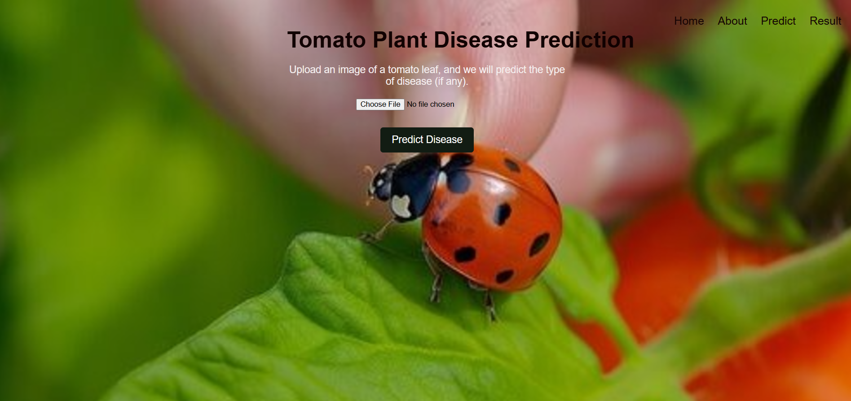

**Result.html is displayed below Input:1**

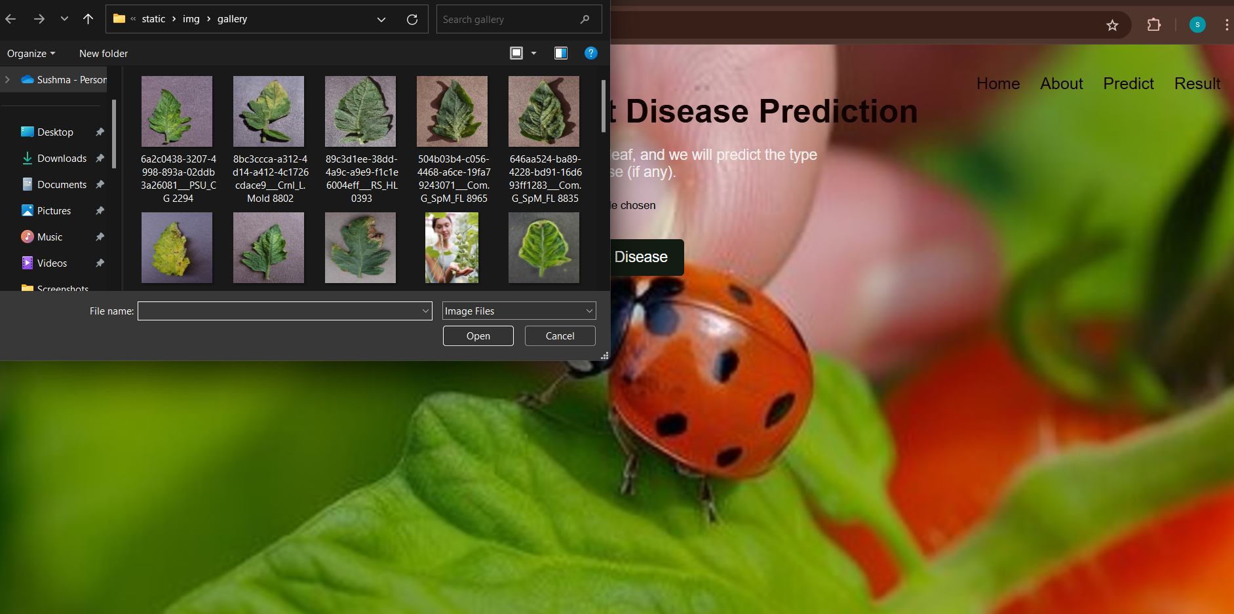

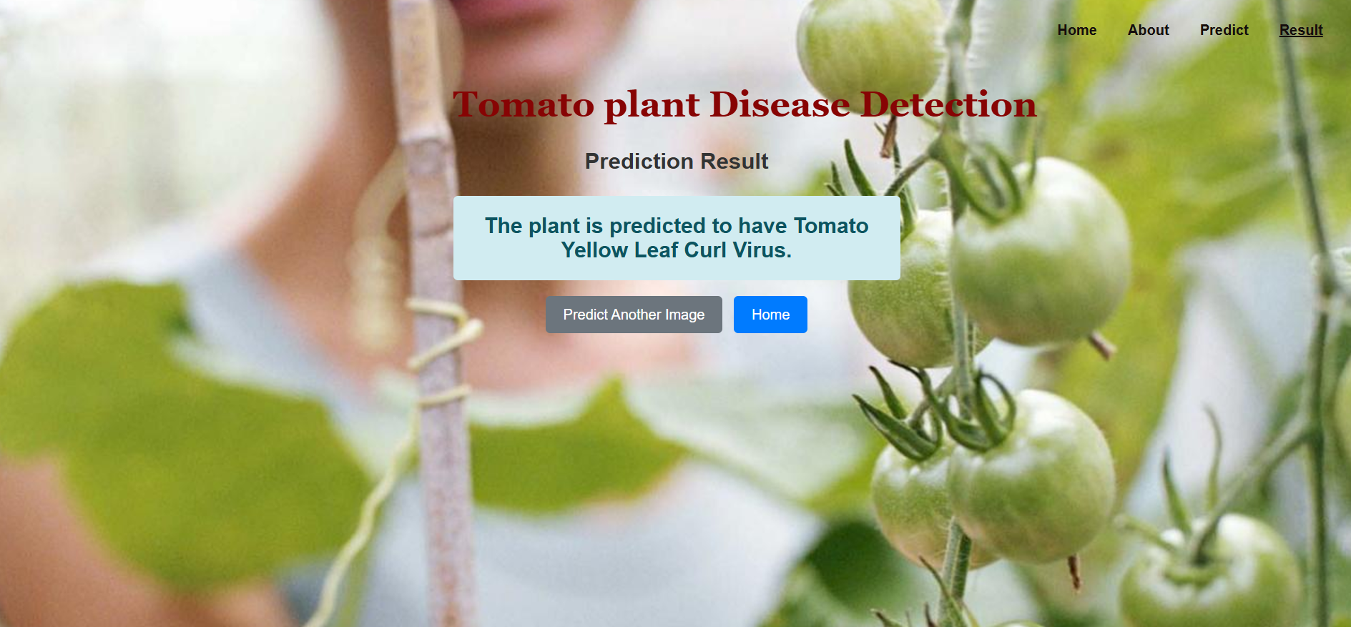

**Input:2**



**Output: 2**

